Great question — this is VERY important for interviews 🔥
Once you recognize a Catalan pattern, you can solve many problems easily.

🧠 What are Catalan Problems?
👉 These are problems where:
- You divide into left + right parts
- Combine results using multiplication
- And sum over all possibilities
👉 Core formula:
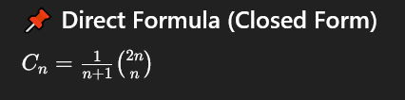
🔑 How to Identify Catalan Problems (Interview Trick)
If you see:
- “Count number of ways”
- “Divide into two parts”
- “Choose a root / pivot / partition”
- “Left * Right combination”
👉 💡 90% chance it's Catalan

🚀 Most Important Catalan Problems
1. Unique BSTs
👉 Already done
- Input: n nodes
- Output: number of BSTs
- Pattern: choose root → left * right

2. Valid Parentheses
👉 Problem: Number of valid parentheses combinations for n pairs
Example:
n = 3
((()))
(()())
(())()
()(())
()()()
👉 Answer = Catalan number

3. Number of Full Binary Trees
👉 Every node has 0 or 2 children
- Count number of such trees with n nodes
- Again → Catalan

4. Ways to Triangulate Polygon
👉 Divide polygon into triangles
- Choose one diagonal → split into left + right
- Same pattern → Catalan

5. Mountain / Valley Problem
👉 Up & Down strokes (same as parentheses)
- Valid sequences → Catalan

6. Non-Crossing Chords in Circle
👉 Connect points on circle without intersections
- Split circle → left + right
- Catalan again

7. Matrix Chain Parenthesization (structure count)
👉 Number of ways to place brackets
- Not cost, just structure count → Catalan

💡 Common Pattern (VERY IMPORTANT)
All Catalan problems follow this structure:
for (i = 1 to n):
left = solve(i-1)
right = solve(n-i)
total += left * right

🔥 Quick Table (Memorize)
 | Catalan(n)
0 | 1
1 | 1
2 | 2
3 | 5
4 | 14
5 | 42

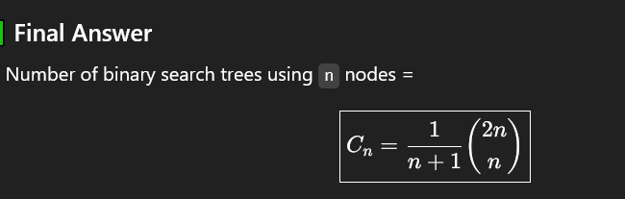
🎯 Interview Strategy
When you see a problem:
👉 Ask yourself:
- Can I choose a pivot/root?
- Does it split into independent subproblems?
- Do I multiply results?
👉 If YES → think Catalan

⚠️ Common Mistake
❌ People confuse with normal DP
✔️ Key difference:
- Catalan = structure-based counting
- Not just sum → sum of products

🔥 Pro Tip (FAANG Level)
Catalan problems are just a special case of:
👉 Divide & Conquer + DP (Overlapping subproblems)

If you want next step, I can:
✅ Give LeetCode questions list (must practice)
✅ Show how to derive Catalan formula in interview
✅ Give tricky variations (hard level)
Just tell 👍

